Lecture 8 – Monitoring human movement using wearable sensors

PART 1: Physics behind sensors and functionality

NEWTONS SECOND LAW:

* Accelerometer
* F = ma How we measure acceleration in systems
* Hooke’s Law : F = -kx
  + Amount of force required to stretch a spring, proportional to the distance needed to be stretched
  + 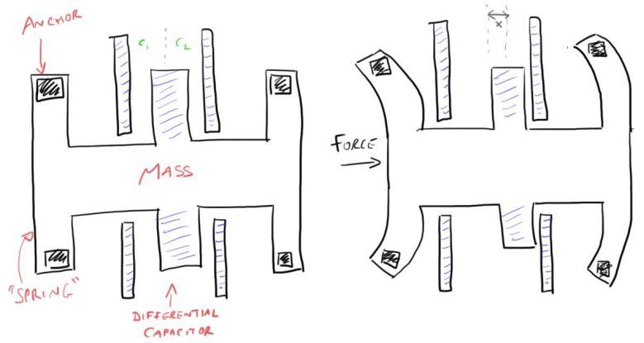If we can measure displacement of the spring, we can figure out the force
  + Spring = beam
    - Force on spring spring bends amount of force depends on 2nd law, F = ma (= -kx) if mass is known, acceleration can be found from displacement (from the bending)
  + Displacement is determined via the different capacitors
    - Different distances from middle plate to outside plate, as well as, relative charges (ie. intensity of attraction)

GYROSCOPES

* Used to determine direction/way of rotation/angular velocity
  + Senses rotation motion + changes in orientation
  + Via change of angle
  + Consists of a wheel or disc that spins rapidly about an axis, with freedom of movement (can change direction)
  + Since orientation of axis is not affected by tilting the mount, it can provide stability or maintain a reference direction in navigation systems, automatic pilots and stabilizers
* 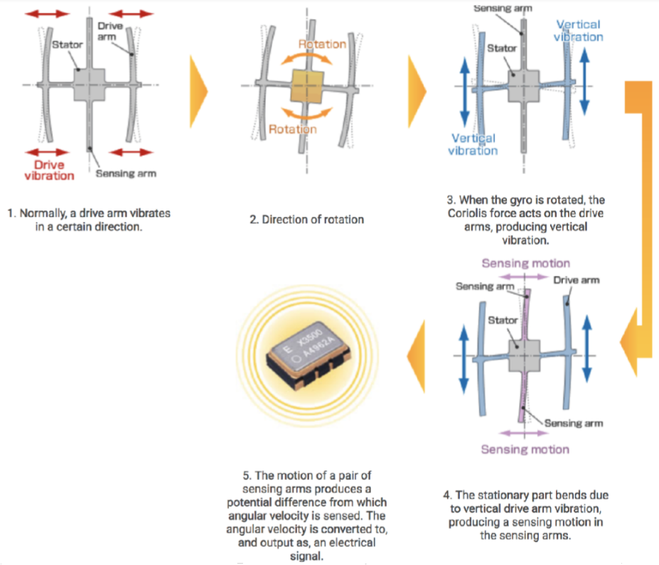Coriolis Effect
  + Pseudo Force effect (force acting on object in rotating frame of reference)
  + Inertial: Acts on objects in motion relative to rotating reference frame
  + Rest Frame: in room
    - Spinning disk in room
    - Put hand over disk and fire a bullet
    - Rotation of disk doesn’t affect bullet’s trajectory; bullet travels straight after being fired
  + Rotational frame: Sitting on disk
    - If hand is put up and a bullet is fired, to me; bullet is going straight up
    - From rest POV, bullet is curving away

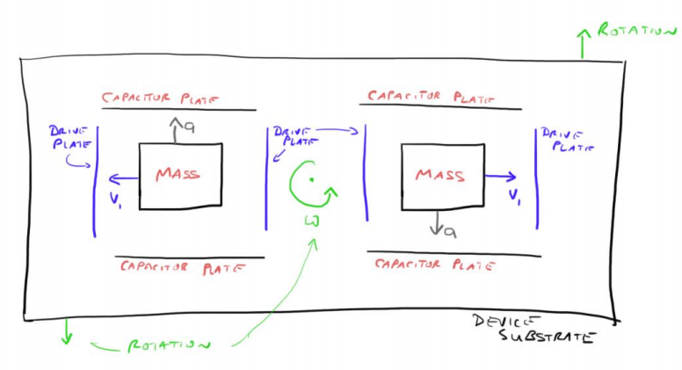MEMS GYROSCOPE

* A differential capacitor (same as accelerometer) to measure displacement
* Mass in capacitor plates shake/vibrate left and right (using coulombs laws) aka. Vibrating gyroscopes
* But once rotated in any way, coriolis effect takes effect
* 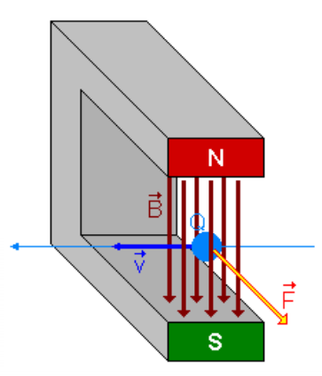When mass moves outward, it accelerates to keep up with the frame. When mass moves to centre, little acceleration needed to keep up with rotation
  + Stationary: mass moves left and right
  + Rotating: mass is deflected up and down
* Can measure displacement for gyroscope via differential capacitor
* Utilizes 2x mass system to keep phone balanced (ie. not vibrate). During movement, mass move perfectly out of phase

MEMS MAGNETOMETER – LORENTZ FORCES

* Easily lost from adding rotations from gyroscopes magnetometer tells us where we fact
* Lorentz force – if a charged particle is moved with some velocity in a magnetic field, it will feel a force
  + F = V x B (cross product)
  + 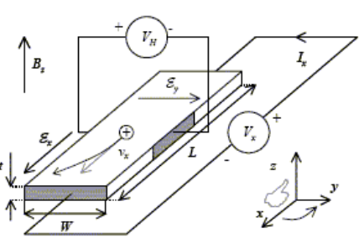Where F is perpendicular (RHPR)
* Application of lorentz force is the hall effect
  + Set up a voltage source, that sends current through a circuit with a s Si semi-conductor (higher resistance than wire, but low enough for current to flow; if current is too high, circuit would explode)
  + Charge moves with velocity experiences Lorentz forces charge piles up/pushed to one side of conductor charge distribution has one side more negative than the other
  + = voltage, indicates presence of magnetic field
  + Needs one in each direction (x,y,z) to detect B-field

ISSUES WITH MEMS MAGNETOMETERS

* 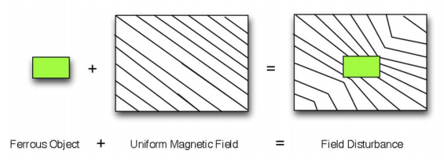Calibration problems too many magnetic distortions
* Soft Iron = interaction of external field with board
  + Ferromagnetic material on sensor board material distorts field lines
* Hard iron = fixed magnetic field on board
  + Magnets on sensor board
  + Permanent distortion = always there, always measuring its magnetic field
* Magnetic Declination
  + Earth’s magnetic field is distorted around Earth compass does not point exactly magnetic north
  + Declination = angle variation on horizontal plane from actual north m
* Magnetic inclination
  + Angle made HORIZONTALLY by Earth’s magnetic field lines
  + At equator, magnetic field goes straight across surface reliable indication of North
  + South pole = almost 90o

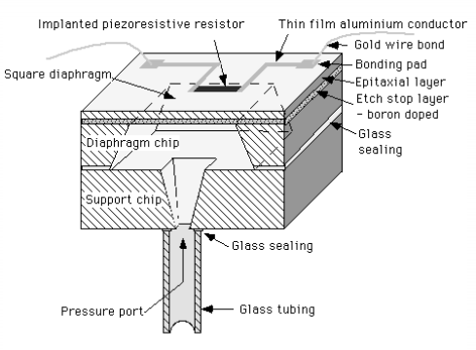MEMS BAROMETER

* Chamber sealed air inside implant piece of resistor on diaphragm (thin skin across hull) resistor changes resistance when stretched
  + As air pressure, outside of chamber, changes, diaphragm:
    - Stretches when moving up, contracts when moving down
    - Measures altitude (but: needs to be calibrated)
    - CONs: pressure changes according to weather (interference)

GPS (Global Positioning System)

* Multilateration; algorithms of distances to determine position
* Needs 4 satellites
  + All satellites contain atomic clocks, synched up (accounting for time delay) sends signal with time stamp phone determines distance between satellites from differences in time stamps
* Special relativity slows time for travelling satellites time delay subtracted

PART 2: Maths of rotation

* 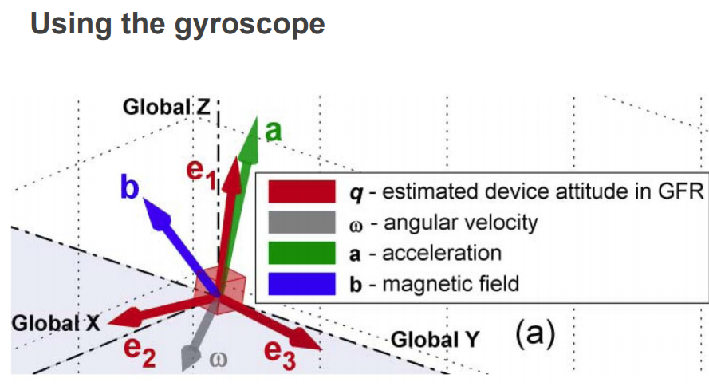Needs to figure out angles between vectors and how to rotate axis angles to determine orientation, given with the data in the gyroscope
* Dot (scalar) product
  + Determines angle between vectors
* Cross (vector) product
  + Finds vector perpendicular to two vectors
* Angular Velocity
  + Angular distance = angle in radians
  + Angle =
  + Angular velocity =
    - Speed is perpendicular to [how fast, it is spinning along the arc]

QUATERNIONS

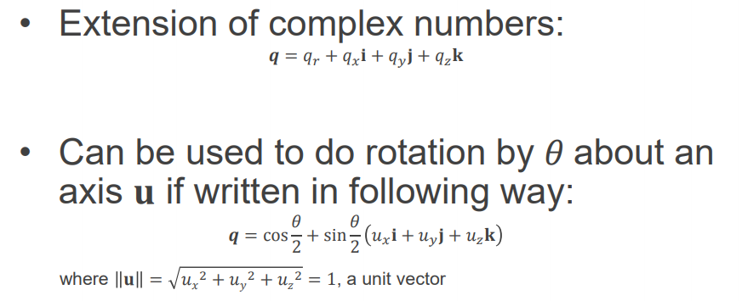

Unit vector can show direction

* Encodes 3D rotation in the word (especially the u-quaternion)
* AXIS – ANGLE ROTATIONS = take a point and rotate it around a given vector in 3D space
  + U = rotation axis
    - Needs unit vector form (divide each component by vector’s total absolute length)
  + v and v’ are endpoints of rotation
  + Takes the vector with a ‘0’ real part at front
  + 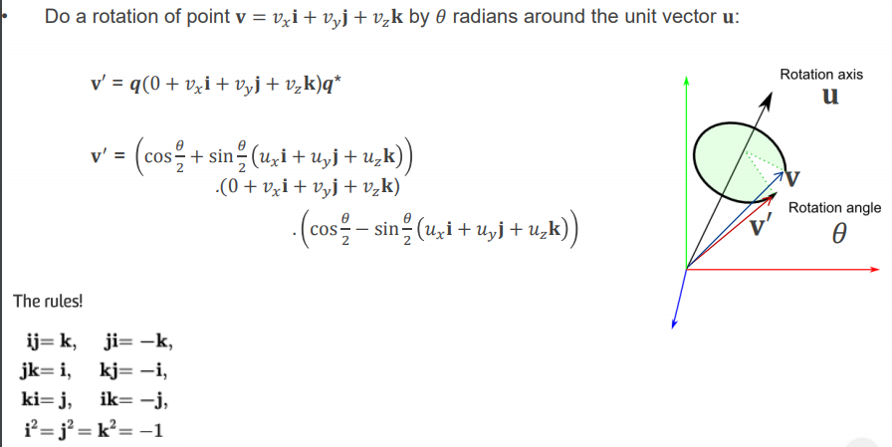Rotation is encoded in q
    - Need to find q and its quaternion conjugate
    - Put it at the start and end = rotation
    - Utilizes the second equation
* Using RH Grip Rule
  + Thumb points in direction of positive z-axis (or axis of rotation)
  + Fingers curl in +

KALMAN FILTER

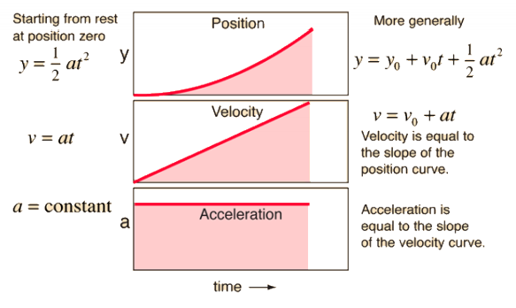= random guess of variables from noisy data (eg. orientations, some angles, progression of data as time progresses)

* Figure out orientation subtract gravity = just acceleration due to movement
  + Integrate it twice to determine position (although inaccurate, due to unknown constants)

DEAD RECKONING

* Sensor on foot every time, foot hits ground = 0 velocity get a trace of vertical vs forward position (x metres)